🚀 Smart Expense Tracker

Production-Grade Personal Finance Analytics Platform
A full-stack financial analytics web application that parses bank statement PDFs, extracts transactions, and generates dynamic visual insights through a modern dashboard.

🏆 Why This Project Stands Out
This is not just a CRUD app.
It demonstrates:
- 🔐 Secure JWT Authentication Architecture
- 📄 Real-world PDF Parsing & Data Extraction
- 📊 Advanced Financial Analytics Dashboard
- 🧠 Category Detection & Monthly Aggregation Logic
- ☁️ Cloud Deployment (MongoDB Atlas + Render + Vercel)
- 🏗 Clean, Scalable Full-Stack Architecture

🌍 Live Application
- Frontend (Vercel): https://personal-finance-tracking-app.vercel.app/
- Backend API (Render): https://finance-backend-1g15.onrender.com/

🖼 Application Preview

🔐 Authentication System
- Register / Login
- JWT Token Generation
- Protected Routes
- Persistent Sessions

📄 PDF Upload & Transaction Extraction
- Upload Bank Statement PDF
- Server-side parsing using pdf-parse
- Extract:
  - Date
  - Description
  - Credit / Debit
  - Balance
- Automatic categorization logic

📊 Financial Analytics Dashboard
- Total Income vs Total Expense
- Monthly Expense Breakdown
- Category-wise Analysis
- Dynamic Charts (Recharts)
- Real-time aggregation from MongoDB

🏗 System Architecture
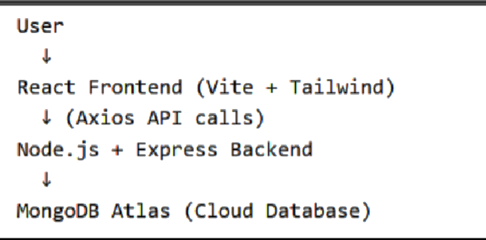

🛠 Tech Stack

🖥 Frontend
- React (Vite)
- React Router v6
- Context API (Auth State Management)
- Axios
- Tailwind CSS
- Recharts (Data Visualization)

⚙ Backend
- Node.js
- Express.js
- MongoDB + Mongoose
- JWT Authentication
- Multer (File Upload Middleware)
- pdf-parse (PDF Data Extraction)
- CORS Configuration

☁️ Deployment
- MongoDB Atlas (AWS - Mumbai Region)
- Render (Backend Hosting)
- Vercel (Frontend Hosting)

🔐 Authentication Architecture
- Password hashed before storage
- JWT signed with secret key
- Token stored in localStorage
- AuthContext hydrates session safely
- ProtectedRoute prevents unauthorized access
- Logout clears token + user state

📊 Data Processing Logic
When a PDF is uploaded:
- File stored temporarily via Multer
- Parsed using pdf-parse
- Transactions extracted using custom logic
- Categorization applied
- Stored in MongoDB
- Aggregated dynamically:
  - Total Income
  - Total Expense
  - Monthly Breakdown
  - Category Totals

📂 Project Structure
personal-finance-tracking-app/
│
├── client/
│ ├── pages/
│ ├── components/
│ ├── context/
│ ├── services/
│ └── App.jsx
│
├── server/
│ ├── routes/
│ ├── controllers/
│ ├── models/
│ ├── middleware/
│ ├── utils/
│ └── server.js
│
└── README.md

🔌 API Endpoints

Auth Routes
Method | Endpoint | Description
POST | /api/auth/register | Register new user
POST | /api/auth/login | Login user

Transaction Routes
Method | Endpoint | Description
POST | /api/upload | Upload & parse PDF
GET | /api/transactions | Get user transactions
GET | /api/summary | Get financial summary

⚙️ Environment Variables

Backend (.env)
PORT=5000
MONGO_URI= mongodb://127.0.0.1:27017/financeApp
JWT_SECRET= supersecretkey123

Frontend (.env)
VITE_API_BASE_URL= https://finance-backend-1g15.onrender.com/

🧪 Local Setup Guide

1️ Clone Repository
git clone https://github.com/kashyap-deepanshu/personal-finance-tracking-app.git
cd personal-finance-tracking-app

2️ Install Backend
cd server
npm install
npm run dev

3️ Install Frontend
cd client
npm install
npm run dev

📈 Engineering Highlights (For Recruiters)
- Real-world financial data processing
- Backend PDF parsing & structured extraction
- Clean separation of concerns
- Scalable architecture
- Secure authentication workflow
- Production cloud deployment
- Environment-based configuration
- Persistent user session handling
- Modular React component structure
- Modern UI/UX with Tailwind

🔮 Future Improvements
- Expense trend prediction
- AI-based smart categorization
- Multi-bank PDF support
- CSV Upload support
- Admin analytics panel
- Dark mode
- PWA support

👨‍💻 Author
Deepanshu
Full-Stack Developer
GitHub: https://github.com/kashyap-deepanshu
LinkedIn: https://www.linkedin.com/in/kashyap1999/

